ILSADE 2018 SPRING

CONFERENCE

MORAINE VALLEY COMMUNITY COLLEGE

PALOS HILLS, IL
  - APRIL 20, 2018

Dear Attendee:
Welcome to ILSADE 2018 – Innovation on a Dime! As we continue to improve the lives of our students, and continue to innovate and develop new programs to ensure that every student can succeed, we continue to attempt to find ways in challenging fiscal budget to do the best we can for our students.
There are so many ways in which we continue to be innovative in challenging academic environments. The last few years have seen Developmental Education put under a microscope, and we have continued to meet and exceed the rising challenge of helping our students succeed.
This commitment to excellence is a product of who we are. The Developmental Educator’s job begins when their students leave; the planning, the evaluation, and meetings we do all complement the work done in class, and the empathy and compassion that permeates every aspect of what we do. As education remains the primary way to provide a living in a post-industrial economy our work will remain vital throughout our students’ lives, and those in the educational field often have no idea how vital they are to the betterment of the world – after all, our students often don’t realize how much we have helped them until years, or decades, after they have left us.
We can’t thank you enough for your attendance and participation. Throughout the day we will learn about cutting-edge best practices in our field, learn about new ideas and implementation at schools throughout the state, and see old friends (and make some new ones).
Please stay connected with us! We love to hear from you and we hope that you stay connected with us through the year. We hope you have a wonderful experience and look forward to seeing you in the Fall for our Fall Retreat!
With Warmest Regards,

Jason King
President,
Illinois Learning Specialists and Developmental Educators
Associate Professor, Developmental Mathematics,
Moraine Valley Community College
March 27, 2018
Dear Fellow ILSADE Members,
Welcome back to Moraine Valley Community College! Once again, we are very excited to host this important conference. It is essential that we congregate and share with each other – the work we do is too significant to lock up in isolated classrooms. Our faculty and staff have worked very hard to raise our success rates in recent years, and we are very eager to learn what you all are doing as well. Together, we can only be stronger.
Have a wonderful conference and please let me know if I can help you in any way.
Sincerely,
Michael Morsches
Michael Morsches
Dean, Learning Enrichment and College Readiness
(708) 974-5310
morschesm@morainevalley.edu

Dear Conference Participants:
On behalf of the Executive Board of the National Association for Developmental Education (NADE), I welcome you to Moraine Valley Community College, Palos Hills, Illinois and to ILSADE’s 2018 Annual Spring Conference. Your conference planning team has planned an outstanding conference that should prove to engage you as a professional developmental educator. The theme, Innovation on a Dime: Stretching Services to Support Students, and the concurrent sessions were all planned with your professional needs in mind. I trust that you will find the conference both valuable and inspiring.
NADE invites you to get involved at the national level to share your expertise and experiences. Please know how important you are to the organization and its success. Join a network, committee, or consider presenting by attending NADE’s 43rd Annual Conference in Atlanta, Georgia, March 6-9, 2019.
I admire your work and dedication. Your work matters to our colleges, communities and most importantly to our students. What you do every day in your classrooms and in your programs makes a positive difference – thank you. I am proud to work with you in these efforts.

Please accept my best wishes for a successful and informative conference.

Dr. Deb Daiek
NADE President

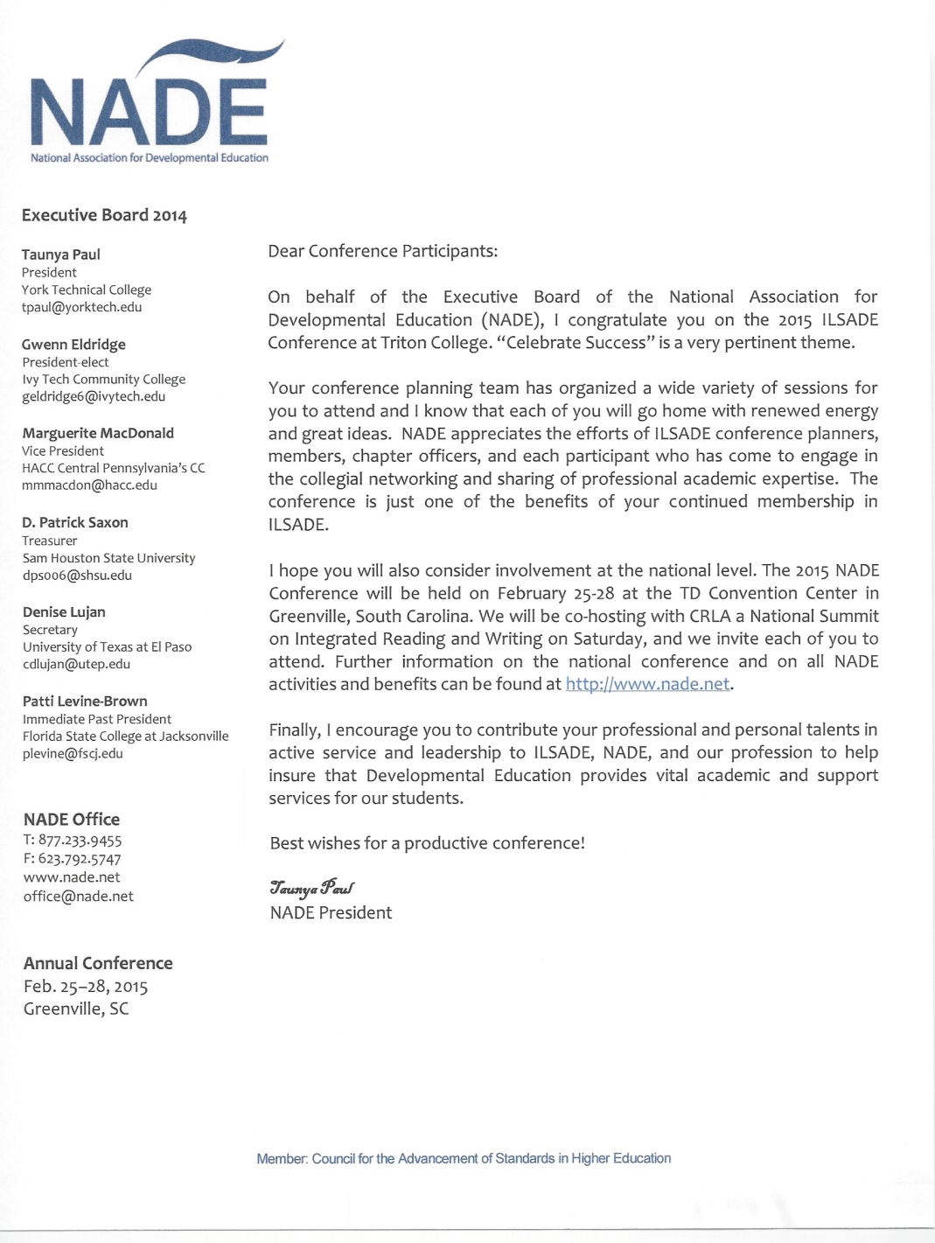
CONFERENCE AGENDA
8:15 - 9:00: Registration and continental breakfast - Moraine Room 3
9:00 – 10:15: Welcome to ILSADE Fall 2018! - Moraine Room 3
- Nina Shoman-Dajani
Assistant Dean, Learning Enrichment and College Readiness
Moraine Valley Community College
- Jason King
Associate Professor, Mathematics and Geography
Moraine Valley Community College
President, ILSADE
Keynote Speakers – Across the Aisle
- Jenny Crones (moderator)
Coordinator of Tutoring Services
Heartland Community College
Secretary, ILSADE
- David Faulkner
- Evan Lundquist
- Charlie Williams
- Darryl Mitchell
10:30-11:20 Presentation Session A (see page 6)
11:30- 12:45: Awards and Lunch - Room M3
Excellence in Education:
Administrator: Robyn Schiffman, IVCC
Staff: Kipp Cozad and Jeffrey Carpenter, MVCC
Faculty: Susan Godwin, MVCC
Adjunct Faculty: Michele Duffy, NIU
Student Scholarship: Charlie Williams, MVCC
1:00 –1:50: Presentation Session B (see page 7)
2:00 – 2:50: Presentation Session C (see page 8)
3:00 – 3:50: Roundtable Sessions (see page 9)

Presentation Session A Options: 10:30 – 11:20
The Best of Both Worlds: Successfully implementing corequisite developmental writing courses Room M206
Lisa Crizer, Adriane Hutchinson, Ellen Morton, Kathy Young – McHenry County College
We now know the benefits of corequisite courses in developmental education. But what happens when we make the switch from traditional, stand-alone developmental courses to a corequisite model? How do we successfully deal with the challenges that comes with implementing these courses? In this session, we will discuss the changes we’ve made to the developmental writing program at McHenry County College. We will share the challenges we’ve encountered, both inside and outside the classroom, and the many ways we’ve worked together to deal with these successfully.
Developmental Reading and College Study Skills: Co-requisite Synergies Room M207
Anna Chmiel, Dan Cristman, Matthew Cullen, Rita Ferriter, Susan Godwin – Moraine Valley Community College
College study skills (COS 100) became a co-requisite of the lowest level reading course offered at the college. A unique plan involving several departments was developed to try to maximize the benefits of the course pairings. The synergies between the courses have improved student success.
Mathematics Roundtable and Open Mic! Moraine Room 3
Jason King, Moderator, Moraine Valley Community College
Let’s get together and talk about our Best Practices in Developmental Mathematics. We’ll have a Math Lesson Open Mic – if you’d like to share any Best Practices you’ve got, this will be a great way to share them with your peers if you’d like. Bring business cards to share with your peers, too!

Program Session Options B 1:00-1:50
ZipGrade - An Alternative to Scantron Room M206
Christopher Riola, Moraine Valley Community College
In this session, we will explore the power of a mobile app known as ZipGrade. Available for Android and Apple devices, users can harness the power of their smartphone or tablet to grade student papers. A limited-use version is available for free, and the full app is available for a nominal yearly subscription. We will cover the basic functionality of the app, as well as creating exams, answer keys, customized answer sheets, and more.
A Glimpse into Developmental Reading at MVCC Room M207
Jennifer Lee, Rita Ferriter, Moraine Valley Community College
Developmental reading courses are structured to maximize comprehension and to build a toolbox of comprehension strategies to apply in textbooks of other college courses. Participants will be given a glimpse inside of a typical developmental reading course at Moraine Valley. An interactive approach will be utilized in the presentation.
Academic Misconduct: The Battle Against Cheating Moraine Room 3
Lara Hernandez Corkrey, Moraine Valley Community College
Sweeping changes in technology have wrought sweeping changes in cheating as well. Gone is the stash of term papers from older siblings waiting to be resubmitted under a new name. In its place are online paper banks, custom essay mills, sharing sites, and even shadow students. As writing teachers, we are on the front line of the war on academic integrity. We are not only the recipients of suspect papers, but we are also considered the experts in identifying the markers of cheating in written work. Let’s get together and discuss the new threats to academic integrity.

Program Session Options C – 2:00- 2:50

Better, Faster, Stronger: Developmental Writing and the Pressure to Reform Room M206
Lara Hernandez Corkrey, Moraine Valley Community College
Formerly seen as the gateway to higher education for underprepared students, developmental education is now commonly referred to as a barrier keeping those same students from completion. States all across America are looking into what they call “remedial reform.” Some states have eliminated stand-alone developmental courses while others are investigating ways to accelerate the progress of these students through bypass options or course compression.

Is your department re-evaluating your approach to developmental writing? What changes have you made to your developmental writing curriculum? How are they working? Let’s discuss both the challenges and opportunities this national dialogue presents.

Not Just a Dime a Dozen: Stretching Vocabulary Instruction to Support Students Room M207
Michele Duffy, Jennifer Theriault – Northern Illinois University

This presentation is geared toward developmental educators interested in the area of vocabulary instruction. As vocabulary is an important aspect of comprehension, instructors need to help build students’ independent word learning strategies. Yet, readily available and college-level appropriate resources for vocabulary instruction for postsecondary educators may be difficult to find. The presentation begins with a theoretical foundation and overview of existing research on postsecondary vocabulary instruction before sharing possible strategies for vocabulary instruction at the postsecondary developmental level. Come see how particular vocabulary strategies can be utilized to stretch students’ learning and success.

(Program Sessions continued on page 9)

Why Don’t They Study? Moraine Room 3
Jason King, Moraine Valley Community College

From the standpoint of many in Developmental Education, it can be easy to ask why our students don’t do the things we know would make them more successful – ask questions, study, complete homework, and buy the book. Why, so often, do our students not complete these? In this session we will explore what Transtheoretical Psychology, a psychological school often used for behavior modification, can tell us – and what steps we can take to help our students succeed.

Keynote Speakers
NOTES
Evan Strandquist
While the age of Evan Strandquist coincides with the age of traditional students, he is far from it. Evan is an 8th grade drop-out who, at the age of seventeen, decided that the life he had ahead of him, with the academic and professional experience of an eighth grader, was something he did not desire. Evan returned to school by means of the adult education GED program at Heartland Community College (a free program he utilized heavily), to teach and refresh himself the basics of mathematics, writing, reading, and the sciences. Upon obtaining his GED, Evan enrolled in a developmental math course and continued on to achieve my educational goals.
Evan is currently a pre-medicine chemistry undergraduate at ISU who works full-time hours between tutoring for HCC and working with the aging population at a local retirement community, Luther Oaks. He has held multiple leadership positions on campus, having been a part of student organized clubs such as the Student Library Advising Committee (SLAC) and PRIDE, as well as his current position as a peer tutor. The duality of both a non-traditional student and peer tutor status has provided him a unique view on the courses he tutors as well as the students who enroll in them. Evan has gone from being classified as "developmental" in his adult-ed GED class to "setting the curve" in his organic chemistry class. He has experienced a broad spectrum of personalities, struggles, hurdles, and blessings on his academic journey and strives to share his experiences with the students he interact with so as to better their learning, as well as his own.
Keynote Speakers
Charlie Williams
Charlie Williams Jr. started attending Moraine Valley Community College in the fall of 2014 at the young age of 60 years old, after receiving his GED. Charlie is majoring in the Addictions Studies Program, with the goal of obtaining his certificate as a Certified Alcohol and Drug Counselor as well as his Associate’s Degree. He is the second person to attend college in his family, and is enjoying his new experience as a college student. Charlie is the oldest of six children and grew up on the south side of Chicago.
Before attending college Charlie’s first profession was in the culinary field, becoming a Chef’s Manager where he worked for 20 years. In 2000 Charlie began suffering from Glaucoma, depression, and was pushed out of a profession he enjoyed. Following this, Charlie worked in an Access to Recovery program with churches until the program was cancelled.

Keynote Speakers
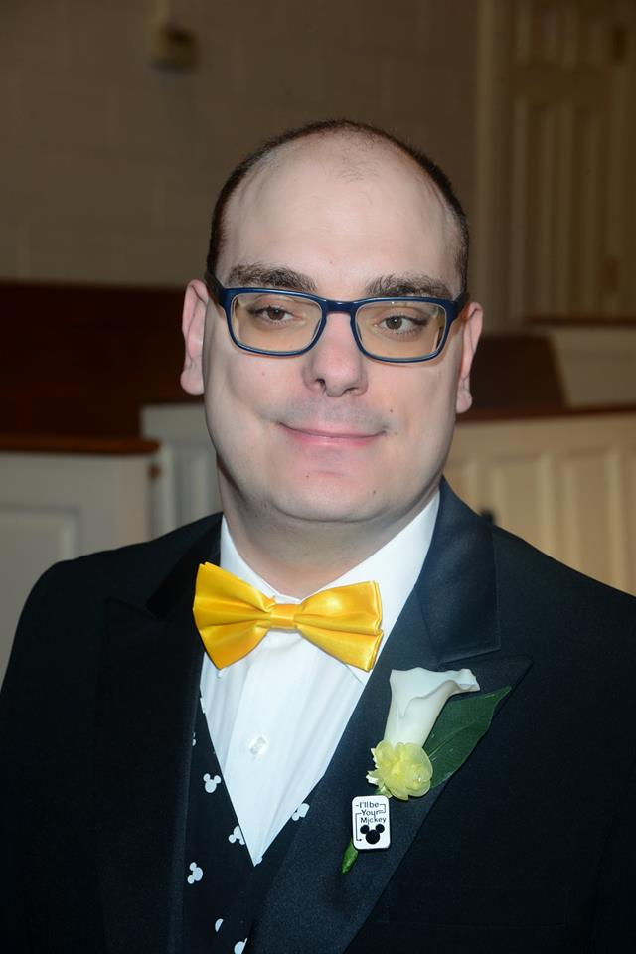
David Faulkner
David Faulkner is honored to be a Keynote Speaker at ILSADE. When David was born, he was born prematurely and suffered two strokes as a baby; the doctors told his parents when he was ten days old that he would not walk or talk. (Suffice it to say, he proved them wrong and then some.) In high school, he received awards for community service. In college at Moraine Valley he was scholarship recipient was named All-Conference several times on the College Bowl/Academic Decathlon team. Currently David works as an award-winning customer service member for FTD.com. David also, within the last year, has begun to drive after doctors told him he would not be able to; since cars are a passion for him owning and driving a car has been a great joy. David married his wonderful wife Megan in 2016, who helps him complete his life.

Keynote Speakers
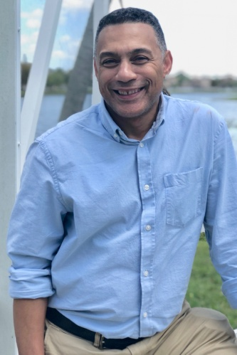
Darryl Mitchell
Darryl Mitchell, Sr. is a fifty-four year old student returning to school after being academically dismissed from college in 1984. Prior to entering college, Darryl routinely struggled with school. In his senior year of high school after getting accidentally shot in his liver, lung, spleen, stomach and pancreas, Darryl almost died. He struggled with his health during his senior year at Kenwood Academy but, thankfully, graduated with his class. With a new start on life, Darryl decided that he wanted to pursue higher education and entered Northern Illinois University in the Fall of 1982. However, he began to struggle with focusing on his coursework. Additionally, his long-term fear of subjects like Math and English resulting from feelings of being belittled and embarrassed by grammar school teachers at a parochial school on Chicago’s south side took a toll. After attempting and failing at writing a term paper in his sophomore year, he felt that his foundation was too compromised to compete at the collegiate level. Because of this hopeless state of mind, he gave up and was, ultimately, dismissed from the university. Darryl has most recently been an entrepreneur in the construction industry and is a licensed Real Estate Broker.
Today, Darryl has a new outlook on academics. He studies almost every day, asks as many questions as he can and seeks out help whenever necessary—steps he never would have taken in the past. He is confident that the style of teaching received at Moraine Valley Community College has had a significant impact on his motivation and has left him determined to obtain his B. A. degree and perhaps even a Master’s Degree!
Award Recipients
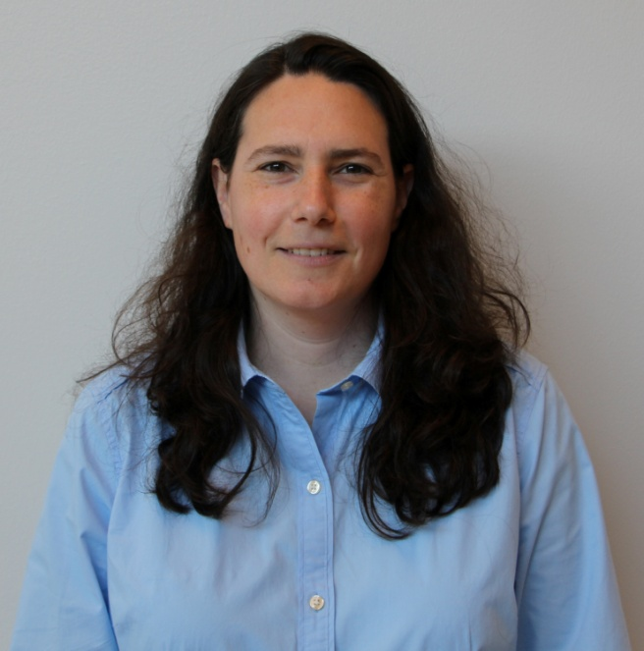
Excellence in Administration
Robyn Schiffman
Illinois Valley Community College
Robyn L. Schiffman is Dean of Humanities, Fine Arts, and Social Sciences at Illinois Valley Community College in Oglesby, IL. Previously she was an Associate Professor of Literature at Fairleigh Dickinson University in Madison, New Jersey. She has been the ILSADE Treasurer for 2 years. She is also the chair of the Modern Language Association’s Committee on Community Colleges and co-chair of the Reducing Remediation Task Force of NIU’s P-20 Network.

Award Recipients

Excellence in Service
Kipp Cozad
Moraine Valley Community College

Kipp Cozad has a bachelor’s degree in Secondary Education and a Master’s of Arts in History. Kipp began his teaching career as a Peace Corps Volunteer in Yemen where he taught ESL to rural Yemeni high school students. Following his overseas stint, Kipp worked at the Plaza Academy in Kansas City, the city’s oldest special education/special needs high school. There he integrated a contingency management behavior model into his social studies curriculum to achieve positive academic results with students that have historically struggled in their previous academic environments.
Following two decades at the secondary level, Kipp became the Tutor and Literacy Coordinator at Moraine Valley Community College. Kipp and Jeff Carpenter, along with the lead tutoring staff have spent the past five years advancing the mission of the center to include an Accuplacer Test Workshop, a Learning Assistance program and have expanded tutoring to include computer tutors in the Moraine Valley Library. Kipp is currently working on an initiative that would move tutoring from a passive entity on campus to an active one through a virtual Learning Commons. In addition to his administrative duties, Kipp serves as an adjunct faculty in history at Moraine Valley.

Award Recipients
Excellence in Service
Jeff Carpenter
Moraine Valley Community College

Jeff Carpenter came to Moraine Valley Community College in 2010 after teaching H.S. English at Chicago Christian H.S. for three decades, coaching H.S. baseball, football, and track & field as well. Tutoring as well as adjuncting in Com and IELP grammar and writing, Jeff became Tutor Specialist in 2014 for the Learning Enrichment and College Readiness division of the college. Along with leading and managing the Com section of the Tutoring Center, Jeff has been involved in the inception of the Bridge Program, a joint venture of MVCC’s Com Dept/ DevEd Dept; he has developed and maintained the Learning Assistant program since 2014; and currently has served as Supplemental Reading/Com Instructor for target cohorts in Developmental Education.

Award Recipients
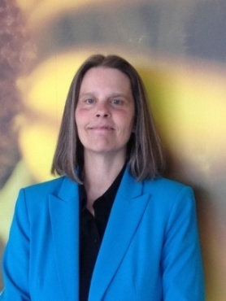
Excellence in Teaching
Susan Godwin
Moraine Valley Community College
Susan Godwin is currently a Professor of Developmental Reading at Moraine Valley Community College where she has been teaching for the last 18 years. She is actively involved in curriculum development in the Developmental Reading Department. Prior to her current position she was a Reading Lab Coordinator at the City Colleges of Chicago where she provided academic and pre- program support services in the areas of Reading and English. Susan is originally from New York State where she was a full time Developmental Reading instructor and coordinated the Reading program at Jamestown Community College (Olean Campus). Her early career was spent in Buffalo, New York as a Developmental Reading and Developmental English instructor at Bryant & Stratton College, as well as teaching Adult Basic Education and tutoring.
Susan presented a pre-conference institute at the national N.A.D.E. conference with colleagues from Moraine Valley Community on a Departmental Course Alignment Project. She has also presented several institutes at national N.A.D.E. and CRLA (College Reading and Learning Association) conferences with a colleague from Jamestown Community College exploring the role of listening in Developmental Reading. Susan is a Reading Specialist; she earned her M.S. Ed in Reading from Canisius College in New York. Also she holds certification in Developmental Education from the Kellogg Institute, and New York State teaching certifications in Reading, English, and English as a Second Language. Susan has a B. A. in Public Communications/Journalism from The State University of New York College at Buffalo, and an A.A. S. in Liberal Arts from Corning Community College in New York. In her leisure time, Susan enjoys spending time at home in Chicago and traveling with her spouse.

Award Recipients
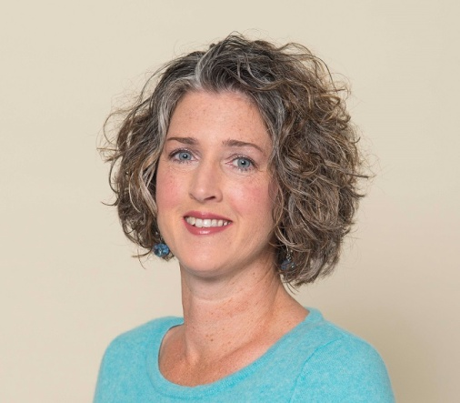
Excellence in Teaching
Michele Duffy
Northern Illinois University and Kishwaukee Community College
Michele Duffy is an adjunct instructor at both Northern Illinois University (NIU) and Kishwaukee Community College (KCC) in DeKalb and Malta, Illinois, respectively. She has been teaching since 2008 in NIU’s Academic Literacy and Learning Program, an intensive program that encompasses reading, writing, and study strategy skills for first-year students. Additionally, she teaches the gamut of developmental education courses at KCC as enrollment dictates.
When Michele is not teaching, she is learning. Currently, she holds a M.A. in English Education with a secondary teaching certificate. Her learning continues as she works toward an Ed.D. in Curriculum and Instruction in Literacy Education with a focus in Postsecondary Developmental Education.

ILSADE Fall 2018
Check the website for updates, blog entries, newsletters, and all sorts of other great stuff!
www.ilsade.weebly.com
Please “like” ILSADE on Facebook for almost-daily information!

